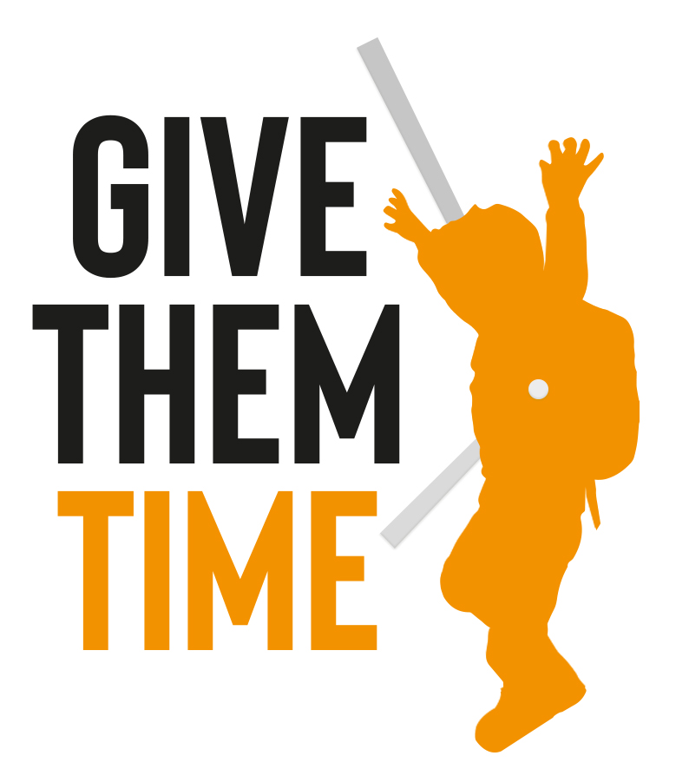
ARTICLES/RESEARCH ON THE POTENTIAL BENEFITS OF DEFERRAL/
A LATER SCHOOL STARTING AGE

Collated by parents from the Give Them Time Campaign – Jan 2020

CONTENTS

SECTION A Impact of Deferral on Attainment
SECTION B Brain Development/Neuroscientific Research
SECTION C Developmental Psychology/Education Research
SECTION D Benefits for Health and Wellbeing
SECTION E The Importance of Language Ability
SECTION F The Importance of Emotional Self-Regulation
SECTION G The Dangers of Learning to Read Too Early
SECTION H Additional Evidence (unsorted as yet)

SECTION A Impact of Deferral on Attainment
1. ‘DELAYING KINDERGARTEN MAY REAP BENEFITS THROUGH ADULTHOOD’ – USA

“A recent study by the National Bureau of Economic Affairs is one of the first to follow redshirted kindergartners into adulthood, and their findings are worth noting. Writing about the study results, NPR notes that “children who start school at an older age do better than their younger classmates and have better odds of attending college and graduating from an elite institution.”

“Researchers found the older children scored higher on college entrance exams, with an achievement gap of almost 40 points on the SAT. Also worth noting is the fact that the socioeconomic level of the children had little to do with any age achievement gaps — meaning even the children of higher-income families with more resources saw the same disadvantages when starting school at age 4.”

2. ‘STUDY SHOWS THAT CHILDREN BORN IN SEPTEMBER ARE MORE LIKELY TO BE SMARTER THAN THEIR COUNTERPARTS’ (2/4/19) USA

“Across 1.2 million students between the ages of 6 and 15 in Florida, it was discovered that September-born kids tend to have a higher cumulative average score each year in school. They had twelve additional months for cognitive, social, and emotional development before they are enrolled in school.”
“The implication of this is that they generally act more mature than their younger classmates. They can handle school and their academic work much better, and they tend to relate more easily with others. The little ones are usually less attached to their parents and are more enthusiastic about going to school.”

3. ‘STARTING SCHOOL LATER IS BETTER FOR CHILDREN’ (2/4/19), Australia

“For each extra month of age, children are showing better developmental skills.”

4. ‘’A GIFT OF TIME’: CHILDREN WHO START LATER FARE BETTER, STUDY SHOWS’ - (9/4/19), Australia

“A quarter of NSW children are starting school a year later than they are eligible, and the delay is helping them fare better in kindergarten than their younger peers, a landmark study has found.”
“Education experts say the study provides further proof that the high cost of child care is forcing many parents to send children to school before they are ready, and have called for investment in free, universal early childhood education...”
5. In October 2015 a study was undertaken in the US & Denmark, “The Gift of Time? School Starting age and Mental Health”. It concludes that an early school starting age may adversely affect educational results because there is a significantly higher incidence of attention deficit problems in children who start formal education at an early age. (National Bureau of Economic Research. Paper# 21610, Thomas S. Dee & Hans Henrik Sievertsen)
6. ‘MORE PLAYTIME AND LESS PRESCHOOL IS THE ANSWER TO A QUALITY EDUCATION’
“Most significantly, a 2008 longitudinal study by psychology professor, Dr. Howard Friedman, of the University of California, Riverside, concluded that "early school entry was associated with less educational attainment, worse midlife adjustment, and most importantly, increased mortality risk." In an article in the United Kingdom's Telegraph, Professor Friedman asserts: "Most children under age six need lots of time to play, and to develop social skills, and to learn to control their impulses. An over-emphasis on formal classroom instruction-- that is, studies instead of buddies, or staying in instead of playing out--can have serious effects that might not be apparent until years later."”
SECTION B Brain Development/Neuroscientific Research
1. 'TEACH KIDS WHEN THEY’RE READY' (15/2/18)
“We now teach reading to 5-year-olds even though evidence shows it’s more efficient to teach them to read at age 7, and that any advantage gained by kids who learn to read early washes out later in childhood...”
“Brain development makes it easier to learn virtually everything (except foreign languages) as we get older. Work is always easier with good tools. You can build a table with a dull saw, but it will take longer and be less pleasant, and may ingrain bad building habits that are hard to break later on.”
2. ‘THE RIGHT BRAIN DEVELOPS FIRST’
Did you know that the right brain develops first? It does so by the time children are 3-4 years of age. The left brain, on the other hand, doesn’t fully come online until children are approximately seven years old; hence the first seven years being recognized as such a critical period in child development.

Understanding this we can better appreciate why play is so important in child learning and development, and why we need to be extra careful with the amount and timing of academic agendas created for children; with how much we emphasize product—what kids have accomplished at school—versus process—who they are becoming and what they feel in their explorations. That the right brain develops first is pertinent information for those in the field of education, as well as parents, regarding what is developmentally appropriate.
3. ‘DEBUNKING THE BELIEF THAT EARLIER IS BETTER’
“As noted early childhood expert Jane Healy once told me, “When you start something before the brain is ready, you’ve got trouble.” Among the possibilities for trouble are enormous stress and even depression. Today, depression among children is at an all-time high.”

4. ‘Premature kindergarten can harm children’s brains’

SECTION C Developmental Psychology/Education Research
1. ‘HOW EARLY ACADEMIC TRAINING RETARDS INTELLECTUAL DEVELOPMENT’ – Dr. Peter Gray, USA (3/6/15)
“It is generally a waste of time, and often harmful, to teach academic skills to children who have not yet developed the requisite motivational and intellectual foundations. Children who haven’t acquired a reason to read or a sense of its value will have little motivation to learn the academic skills associated with reading and little understanding of those skills. Similarly, children who haven’t acquired an understanding of numbers and how they are useful may learn the procedure for, say, addition, but that procedure will have little or no meaning to them.”
“Our brains are designed to hold onto what we understand and to discard nonsense. Moreover, when the procedures are learned by rote, especially if the learning is slow, painful, and shame-inducing, as it often is when forced, such learning may interfere with the intellectual development needed for real reading or real math.”
This explains why researchers repeatedly find that academic training in preschool and kindergarten results in worse, not better, performance on academic tests in later grades (see here). This is also why children’s advocacy groups—such as Defending the Early Years and the Alliance for Childhood—are so strongly opposed to the current trend of teaching academic skills to ever-younger children. The early years, especially, should be spent playing, exploring, and developing the intellectual foundations that will allow children to acquire academic skills relatively easily later on.
In the remainder of this post, I review some findings, discussed in earlier essays in this blog, that illustrate the idea that early academic training can be harmful and that academic learning comes easily once a person has acquired the requisite intellectual foundation and wants to learn the academic skills.
2. ‘HOW TWISTED EARLY CHILDHOOD EDUCATION HAS BECOME FROM A CHILD DEVELOPMENT EXPERT’ (24/11/15)

SECTION D Benefits for Health and Wellbeing
1. ‘TOO MUCH TOO YOUNG: SHOULD SCHOOLING START AT AGE 7?’ (13/11/13)
“AT WHAT age should children start formal schooling? England is one of a few countries to say the answer is as young as 4 years old.
A long-running debate on this question has been reignited by a letter, signed by about 130 early childhood education experts. It called for an extension of informal, play-based preschool provision and for the start of formal schooling in England to be delayed until the age of 7, from the current effective start at age 4.
This would bring it in line with the overwhelming evidence showing that starting school later is best, and the practice in many countries, such as Sweden and Finland. These countries have better academic achievement and child well-being, despite children not starting school until age 7.”
2. In a 2004 longitudinal study of 3,000 children funded by the department of education itself, Oxford’s Kathy Sylva and colleagues showed that an extended period of high-quality, play-based pre-school education made a significant difference to academic learning and well-being through the primary school years.

3. ‘THE RIGHT BRAIN DEVELOPS FIRST’
Pushing literacy and numeracy on children before age seven may just be harmful to their little, developing brains. Without the capacity to use their academic minds in the ways that are being asked can cause children to gain what’s called “learned stupidity.” They believe themselves to be incapable and lose their natural desire to learn.
4. ‘DEBUNKING THE BELIEF THAT EARLIER IS BETTER’
“As noted early childhood expert Jane Healy once told me, “When you start something before the brain is ready, you’ve got trouble.” Among the possibilities for trouble are enormous stress and even depression. Today, depression among children is at an all-time high.”

5. ‘MORE PLAYTIME AND LESS PRESCHOOL IS THE ANSWER TO A QUALITY EDUCATION’ “Most significantly, a 2008 longitudinal study by psychology professor, Dr. Howard Friedman, of the University of California, Riverside, concluded that "early school entry was associated with less educational attainment, worse midlife adjustment, and most importantly, increased mortality risk." In an article in the United Kingdom's Telegraph, Professor Friedman asserts: "Most children under age six need lots of time to play, and to develop social skills, and to learn to control their impulses. An over-emphasis on formal classroom instruction-- that is, studies instead of buddies, or staying in instead of playing out--can have serious effects that might not be apparent until years later."”
6. ‘TEEN DEPRESSION RISK TO YOUNGEST PRIMARY SCHOOL STARTERS’: https://www.standard.co.uk/news/health/teen-depression-risk-to-youngest-primary-school-starters-a4244301.html
7. Hard Evidence: At What Age are Children Ready for School?
The youngest children in a school year are 30% more likely to have depression 'because they struggle to concentrate, grasp lessons or make friends with their older peers'

SECTION E The Importance of Language Ability

- Oral Language Skills report from the Office of Communication Champion

“Researchers have found that, after controlling for a range of other factors that might have played a part (mother’s educational level, overcrowding, low birth weight, parent a poor reader, etc), children who had normal non-verbal skills but a poor vocabulary at age 5 were at age 34 one and a half times more likely to be poor readers or have mental health problems and more than twice as likely to be unemployed as children who had normally developing language at age 5 (Law et al., 2010).”

and “Poor language is linked to poor behaviour”

2. The Complex Relationship Between Speech, Language And Communication Needs And Mental Health, 10/2/18, (Mary Hartshorne Director of Outcomes and Information for I CAN, the children's communication charity and a qualified Speech and Language Therapist -

“In a recent Public Health England Report, good communication skills were identified as supporting resilience when it comes to mental health. Interestingly, the same report identified communication difficulties as risk factors for mental ill health, indeed many studies show that the likelihood of mental health difficulties is increased where children have persistent language difficulties.”

3. THE KEY TO SOCIAL MOBILITY LIES IN LANGUAGE (Bob Reitemeier, Chief Executive of Children's Communication Charity I CAN, 11/7/18)

“Language is the fundamental life skill for children. It directly impacts on their ability to learn, to develop friendships and on their life chances. Even at the age of 2, language ability can strongly predict a child's subsequent performance on school entry assessments. The most important factor in reaching the expected levels in English and maths aged 7 is children’s language skills when they are 5. This is greater than the link to poverty or parental education.”

4. READING TOO SOON
“Children’s neurological pathways for reading, writing, and spelling are not formed yet at these young ages, therefore they are not equipped. In child development you can not miss, shortcut, or rush steps, it just doesn’t work.
Between 3 and 7 years old, predominantly the right side of the brain is developing. The right side of the brain is not where word reading takes place. The right side sees pictures and shapes and uses mental imagery to create the movie in their mind to understand the story. The left side of the brain is where we read words, it is responsible for decoding words into letters and phonetically sounding them out. This is true word reading. It is not until about age 7 that the corpus callosum fully connects the left and right hemispheres of the brain to make reading complete for kids.
By making children read when they really only have access to the right side of their brain, they are forced to memorize what words look like by shape and guess, opposed to being able to sound them out. Not true reading. Also, when kids are focused on memorizing what the words look like by shape, they are not using their right brain to create the movie in their mind, leading to low comprehension.

- 7 Benefits of Waldorf’s “Writing to Read”
This sums up why we shouldn't be forcing children to read and write before their oral language skills are sufficiently developed.

SECTION F The Importance of Emotional Self-Regulation

1. READING TOO SOON

“intellectual and emotional “self-regulation”. This helps them develop awareness of their own mental processes – skills that have been clearly demonstrated to be the key predictors of educational achievement and a range of other positive life outcomes.”

2. KINDERGARTENERS WITH THESE TWO SKILLS ARE TWICE AS LIKELY TO GET A COLLEGE DEGREE ACCORDING TO 19 YEAR STUDY

“researchers discovered that the skills that predict future success had nothing to do with reading or writing. Instead, they say your child's social and emotional skills are what determine how likely your child is to go to college rather than end up in jail.”

3. NOT SO CLEVER? – Naomi Fisher, British Clinical Psychologist
“We also know from research that children’s self-perception of their abilities affects how they do later in life, independently of their actual abilities at the time. That seems to me really important. If children think they are capable of something, then they perform better on that thing later in life — even if they weren’t actually that capable (as compared to their peers) to begin with.”

SECTION G The Dangers of Learning to Read Too Early
1. ‘THE RIGHT BRAIN DEVELOPS FIRST’
Pushing literacy and numeracy on children before age seven may just be harmful to their little, developing brains. Without the capacity to use their academic minds in the ways that are being asked can cause children to gain what’s called “learned stupidity.” They believe themselves to be incapable and lose their natural desire to learn.
- “In their report Reading in Kindergarten: Little to Gain and Much to Lose, education professor Nancy Carlsson-Paige and her colleagues warn about the hazards of early reading instruction. They write, ‘When children have educational experiences that are not geared to their developmental level or in tune with their learning needs and cultures, it can cause them great harm, including feelings of inadequacy, anxiety and confusion’”
- Studies in New Zealand comparing children who began formal literacy instruction at age five or age seven have shown that by the age of 11 there was no difference in reading ability level between the two groups. But the children who started at five developed less positive attitudes to reading, and showed poorer text comprehension than those children who had started later. This is in contrast to Scotland where a study in 2018 showed that at age 11, on average, children’s reading age is one year behind their actual age and by 16 it’s 3 years behind.
- Reading Readiness Has to Do with the Body

SECTION H Additional Evidence (unsorted as yet)
1. Please see the vast amount of evidence gathered by Upstart Scotland.

2. A 2015 report by the Early Childhood Teachers’ Association (ECTA) revealed that 60% of teachers surveyed believed children shouldn’t start school before the age of five and the EIS, Scotland’s largest teaching union voted unanimously at their June 2019 conference in support of the introduction of a statutory kindergarten stage.

3. The evidence from international comparisons of children’s attainment at age 15 and psychological research of young children’s development all points to the advantages of a later start to formal instruction, particularly in relation to literacy.

- ‘HARD EVIDENCE: AT WHAT AGE ARE CHILDREN READY FOR SCHOOL?’ (11/7/14)

“the vast majority of other European countries, many of which currently enjoy higher levels of educational achievement. In Europe, the most common school starting age is six, and even seven in some cases such as Finland.”

- ‘Delay Schooling for Happier, More Well-Adjusted Children’
- ‘Deciding whether or not to send your four-year-old to school? Consider this first’
- ‘Some schools have stopped grouping kids by age -- and it's making a big difference’
- When is the best age to start school? How about 7?
- 4 Things Worse Than Not Learning To Read In Kindergarten
- 'Better off playing': The Sydney school banning four-year-olds
- Summer baby school delays: Parents face postcode lottery
- Are the school odds stacked against summer babies?
- Schools should adjust test scores by age to tackle disadvantage facing summer-born children, experts say
“Parents agonise”: One in ten January-born kids held back from kindy
15. Summer-born fall 19 points behind peers in early years

