RELEVANT QUESTIONS ASKED AS PART OF FREEDOM OF INFORMATION REQUEST SENT TO ALL SCOTTISH LOCAL AUTHORITIES ON 2/9/18
Q2. Please provide an overview of each stage of the local authority's procedure for dealing with discretionary deferral requests from parents of mid-August to December born children.
Q3. Does the council have a timeline for each stage of the process detailed in question 2. to be completed and if so, please provide the timeline for each stage.
Q4. Please provide the job title of all council employees involved in providing information for and/or making a decision about a parental discretionary deferral request.
Q5. Please provide the salary scale for the job title of each employee listed in question 4.

- Falkirk Council
(From Falkirk Council’s website - http://www.falkirk.gov.uk/services/schools-education/school-admissions/docs/2%20Additional%20Pre-school%20year.pdf?v=201809111030&fbclid=IwAR1CIiPztHD0lEmwz8DGBiRqufzOMF5lDLxAE7TEiWn9IiMTY5UusuLVxUc)

2. Angus Council
(Freedom of Information Request sent 2/9/18)

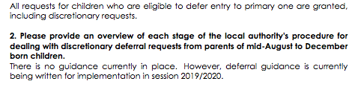

3. South Lanarkshire Council
(Freedom of Information Request sent 2/9/18)

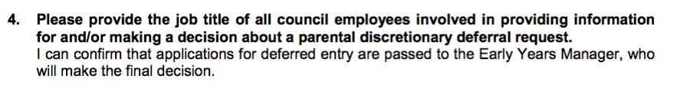

4. Glasgow City Council
(Freedom of Information Request sent 2/9/18)
Q2 RESPONSE

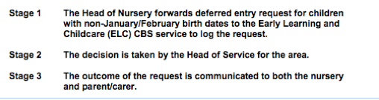

5. North Lanarkshire Council
(Freedom of Information Request sent 2/9/18)

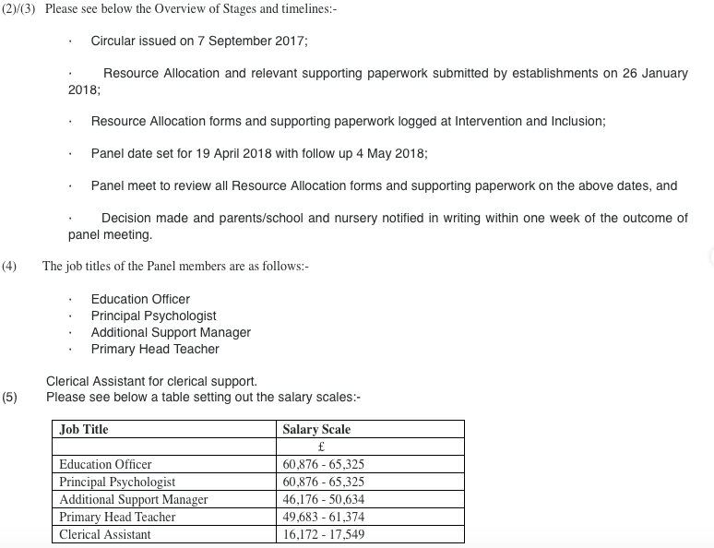

6. East Dumbartonshire Council
(Freedom of Information Request sent 2/9/18)

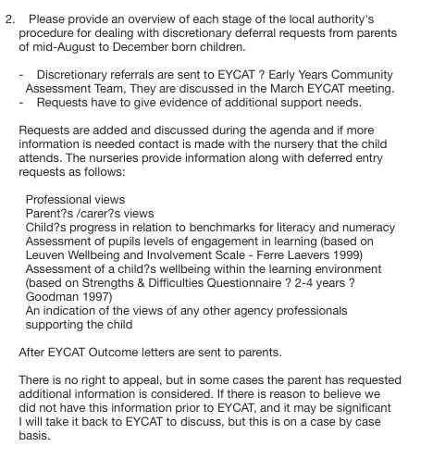

7. West Lothian Council
(Freedom of Information Request sent 2/9/18)

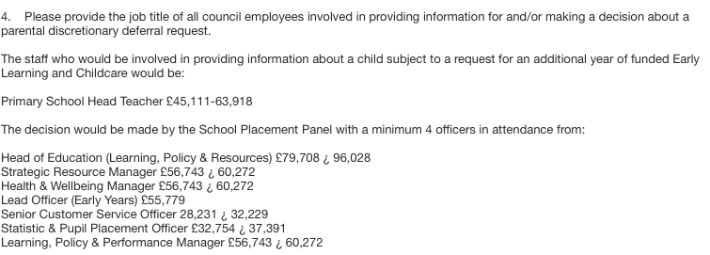

8. East Ayrshire Council
Circular02b (Revised Jan 2016)
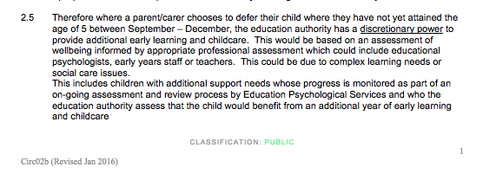

(Freedom of Information Request sent 2/9/18)

